
Please complete all the important (#) details below. If any are missed the details may be cleared when submitting and will need to be re-entered. If the bird had any colour rings please fill them into the correct positions (# important coloumn). If you have trouble filling this form, please email the ring details to bands@bnhs.org along with the photos

Band SIGHTING details

Bird Name / Species# |  | Enter Common/Scientific Name
Location Name# |  | Click or tap here to enter text.
Latitude | Click or tap here to enter text. |  | Longitude |  |  |  | Click or tap here to enter text.
Landmark# |  | Click or tap here to enter text.
Date Observed# |  | Click or tap to enter a date.
State/Province# |  | Click or tap here to enter text.
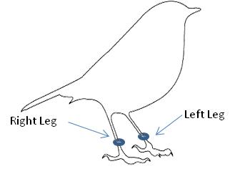  Metal Ring on#: |  | Right Leg |  | ☐
 |  | Left Leg |  | ☐
 |  | (Please select in the appropriate box)
Ring Position#: |  | Above knee (Tibia) |  |  |  | ☐
 |  | Below knee (Tarsus) |  |  |  | ☐
Numbers/Letters Inscribed |  | Click or tap here to enter text.
Bird Status (Alive/Dead/Injured/Trapped) # |  |  |  |  | Click or tap here to enter text.
Further Information  on Bird Condition |  | Click or tap here to enter text.
Further Information  on tag |  | Click or tap here to enter text.
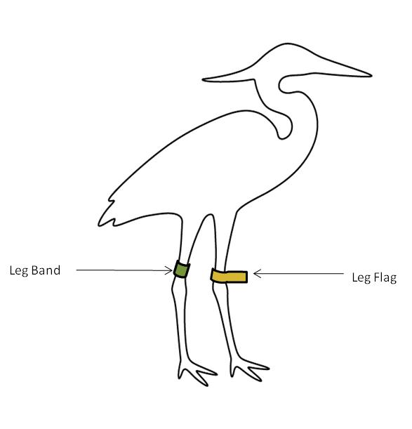
Any additional tags/ flags

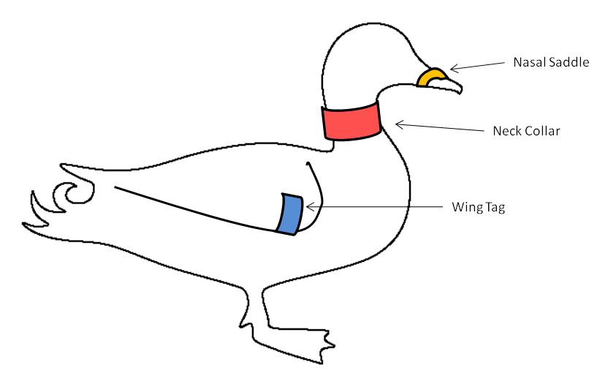
(Please select the appropriate box

Leg flag  ☐ | Neck Collar  ☐ |  |  | Wing Tag  ☐ |  | Geolocator  ☐
Leg band  ☐ | Nasal Saddle  ☐ |  |  | Satellite transmitter  ☐
Tag Colour |  | Click or tap here to enter text.
Tag Inscription |  | Click or tap here to enter text.
Leg tag on |  | Right Leg | ☐ |  | Left Leg |  | ☐
Additional Information  on Bird sighting |  | Click or tap here to enter text.
Contact Details # |  | Name/s, e-mail address, contact number of observer(s)

Please attach images if any and send this filled form to BNHS through the mail id : bands@bnhs.org or post a copy of the form to

Wetlands Programme,
Bombay Natural History Society.
Hornbill House, Dr. Salim Ali Chowk, S.B. Singh Road,
Mumbai 400 001, Maharashtra, India.
Tel.: (91-22) 22821811; Fax: (91-22) 22837615,
Email:info@bnhs.org; Website: www.bnhs.org

